Dody Rachmat Wicaksono  
dodyrw@gmail.com, Des 10 2010

[www.nicecoder.com](http://www.nicecoder.com)

This document is intended to be used for Indexu Deluxe 2.4

How to add company logo for each listing

# Introduction

If you want to use indexu as business listing, it would be nice to have the company logo displayed along with company title and description in the listing page. This tutorial cover basic setup, how to display default logo when there is no logo uploaded and how to setup logo for paid listing only.



# Add new custom field called ‘logo’

Go to admin panel > Links > **Custom Field**

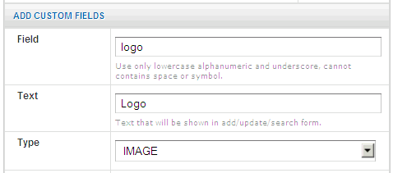

* Field : logo
* Text : Logo
* Type : IMAGE
* Required : No
* Searchable : No
* Permission : All user
* Max Image Dimension : 120px X 60px
* Max File Size : 500
* Allowed File Extension : gif,jpg,png

After adding a new custom field, this custom field will appear in submit / modify form in public page and admin panel as well automatically.

In admin panel:

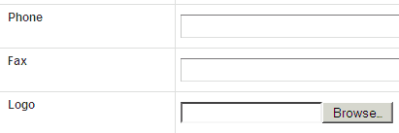

In public page:

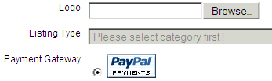

# Placing logo in listing page

This should be done manually. You need to edit template files called rows.html for listing page (browse by category, by tags, and search result. To show the logo, add this code:

<img src="<%$logo%>">

The above code contain <img> tag to display the image. The important part is adding the custom field variable that we use here, in our case it is called logo.

There are other template files that you may want to change as well.

* premium_rows.html : listing for premium listing
* sponsored_rows.html : listing for sponsored listing
* detail_link.html : detail page

# Default logo

Sometimes a listing doesn’t have logo. Instead of leave it a blank space, it is a good idea to put default logo image. It is usually in a grey color with some text like ‘your logo here’.

You need to check whenever logo file is available or not. In indexu you can use if .. else .. clause to do this work. Here is the working code to place default logo file if logo file is not exist.

<%if $logo%>  
 <img src="<%$site_url%>/<%$logo%>" />  
 <%else%>  
 <img src="<%$tpl_base%>/images/nologo.jpg" />  
<%/if%>

# Logo is for paid listing only?

Another idea is to charge for paild listing (premium/sponsored) if the company want to have their logo appear in the directory.

From my earlier explanation, you can use premium_rows.html and sponsored_rows.html to make paid listing appear differently.

There is also another way to detect whenever a listing is premium or sponsored. You can use the following code block. Notice it mention about sponsored sponsored and premium. In the else code block it will be used for basic / free listing.

<%if $sponsored%>  
 .....  
<%elseif $premium%>  
 ......  
<%else%>  
 ......  
<%/if%>

Github page:   
https://github.com/dodyrw/indexu-doc